***Home Heaven E-commerce Website***

Waterfall Deliverables – Part -1/2

**Document 1- Business case document**

**➢ Why is this project initiated?**

The Home Heaven eCommerce project is initiated to provide small businesses with an online platform to sell their products efficiently. Many small vendors struggle with digital presence, secure payment processing, and customer engagement. The current problems include a lack of visibility for small businesses, difficulty in managing inventory online, and limited payment options for customers. These issues create challenges in scaling their business and reaching a wider audience.

**➢ What are the current problems?**

Many existing eCommerce websites have high transaction fees, complex user interfaces, and limited customer support for small businesses. Vendors often face difficulties in managing their stores, handling payments, and maintaining customer engagement, which affects their profitability.

**➢ With this project how many problems could be solved?**

This project will address multiple challenges by offering a seamless, vendor-friendly platform. It will provide easy store setup, secure payment integration, and efficient order tracking. With this solution, issues like high platform fees, slow customer support, and inventory mismanagement can be minimized, improving vendor satisfaction and business growth.

**➢ What are the resources required?**

To build and maintain Home Heaven, we need a strong development team, cloud hosting services, secure payment gateways, and marketing efforts to attract vendors and customers. Additionally, a dedicated customer support team will be essential for smooth operations.

The successful implementation of the project will require resources including:

*1.Human Resources*

• **Project Manager**: Oversees the project.

• **Business Analyst**: Gathers and analyzes requirements.

• **Developers**: Build the portal.

• **UI/UX Designers**: Design user interfaces.

• **Testers**: Ensure functionality and reliability.

• **IT Support**: Handle deployment and support.

*2.* *Technical Resources*

• **Development Tools**

• **Design Tools**

• **Testing Tools**

• **Hosting Infrastructure**: Servers, database systems.

• **Security Tools**: Data protection software.

*3.* *Financial Resources*

• **Budget**: For salaries, software licenses, hardware, and training materials.

*4.* *Physical Resources*

• **Workspace**: Offices or remote setups.

• **Hardware**: Computers, servers, networking equipment.

*5.* *Documentation and Training Materials*

• **User Manuals**: Guides for portal use.

• **Training Programs**: Structured training sessions.

**➢ How much organizational change is required to adopt this technology?**

Businesses adopting Home Heaven will need minimal changes. Vendors only need to register on the platform, upload their products, and start selling. Training will be provided to help them manage their stores effectively.

**➢ Time frame to recover ROI?**

With strategic marketing and vendor onboarding, the estimated timeframe to recover the initial investment (ROI) is around **12-18 months**. This depends on platform adoption, customer engagement, and transaction volume.

**➢ How to identify Stakeholders?**

systematically brainstorm and list all individuals, groups, or organizations that could be affected by or have an influence on a project, initiative, or decision, considering their potential interests, power, and impact on the outcome

Stakeholders include **business owners, vendors, customers, developers, and marketing teams**. Identifying them involves analyzing their roles, interests, and influence on the project. Engaging with them through meetings, surveys, and feedback sessions ensures smooth project execution and success.

**Document 2: BA Strategy**

### **Business Analyst Approach Strategy for Home Heaven eCommerce Website**

As a **Business Analyst (BA)** for the **Home Heaven eCommerce Website**, the following structured approach will be followed to ensure project success

### **1. Elicitation Techniques**

Gathering requirements from stakeholders is crucial for project success. The best techniques include:

* **Interviews** – Conduct discussions with business owners, vendors, and customers to understand their needs.
* **Workshops** – Arrange brainstorming sessions with stakeholders to gather insights.
* **Surveys & Questionnaires** – Collect feedback from potential users to identify expectations.
* **Document Analysis** – Review existing eCommerce models to identify gaps and improvements.
* **Observation** – Study competitor platforms to understand user behavior.
* **Prototyping** – Develop wireframes or mockups for stakeholder validation.

### **2. Stakeholder Analysis (RACI/ILS)**

To ensure clarity in responsibilities, stakeholders will be classified using:

* **RACI Matrix (Responsible, Accountable, Consulted, Informed):**
  + **Responsible:** Developers, UI/UX Designers, QA Testers.
  + **Accountable:** Business Owners, Project Managers.
  + **Consulted:** Vendors, Customers, Marketing Team.
  + **Informed:** Investors, Regulatory Bodies.
* **ILS (Interest, Level of Influence, Support):**
  + **Interest:** Customers and Vendors using the platform.
  + **Influence:** Business Owners, Investors, Compliance Officers.
  + **Support:** IT Support, Customer Service Teams.

| **Stakeholder** | **Responsible (R)** | **Accountable (A)** | **Consulted (C)** | **Informed (I)** |
| --- | --- | --- | --- | --- |
| Business Owners |  | A | C | I |
| Vendors | R |  |  | I |
| Customers |  |  |  | I |
| IT Staff | R |  | C | I |
| Project Manager | R | A |  |  |
| Business Analyst | R |  |  |  |
| UI/UX Designers | R |  |  |  |
| Testers | R |  |  |  |
| Trainers | R |  |  |  |
| Marketing Team |  |  | C | I |
| Investors |  |  | C | I |

#### **2. Documents to Write**

To ensure structured project execution, the following documents will be prepared:

* **Business Requirements Document (BRD)** – Defines business goals and project scope.
* **Functional Requirements Specification (FRS)** – Details system functionalities and technical needs.
* **Use Case Documents** – Illustrates user interactions with the eCommerce website.
* **User Stories** – Defines end-user requirements for development.
* **Test Plan** – Outlines testing procedures to ensure functionality.
* **User Acceptance Testing (UAT) Plan** – Ensures the system meets business needs before launch.
* **Training Materials** – Guides users on how to use the platform efficiently.
* **Project Management Plan** – Defines scope, timeline, resources, and risk management strategies.

#### **3. Document Sign-Off Process**

1. **Draft Preparation** – The Business Analyst will create initial drafts.
2. **Stakeholder Review** – Documents will be shared with stakeholders for feedback.
3. **Incorporate Revisions** – Necessary changes will be made based on feedback.
4. **Formal Approval** – Business Owners and Project Managers will provide final sign-off.
5. **Version Control** – Maintain proper versioning to track updates.

#### **4. Client Approvals**

1. **Final Presentation** – Key documents will be presented to the client.
2. **Clarifications** – The Business Analyst will provide explanations as needed.
3. **Approval Process** – Formal approval will be obtained via signed agreements or email confirmation.

#### **5. Communication Channels**

* **Regular Meetings** – Weekly and monthly meetings to discuss progress.
* **Emails & Reports** – Official documentation and status updates.
* **Collaboration Tools (Jira, Trello, Slack)** – For real-time tracking.
* **Open Feedback System** – Stakeholders can raise concerns anytime.

#### **6. Change Request Handling**

1. **Request Logging** – All change requests will be recorded.
2. **Impact Analysis** – Evaluate how changes affect cost, timeline, and functionality.
3. **Approval Process** – The Change Control Board will review and approve changes.
4. **Implementation** – Approved changes will be integrated into the system.

#### **7. Progress Reporting to Stakeholders**

* **Milestone Reports** – Updates on completed and pending deliverables.
* **Project Dashboards** – Real-time tracking using project management tools.
* **Presentations & Meetings** – Summarize progress, achievements, and risks.

#### **8. UAT & Client Project Acceptance**

1. **UAT Planning** – Define test cases covering critical system functions.
2. **Client Testing** – Provide access to the platform for user validation.
3. **Bug Fixes & Refinements** – Address client feedback and retest.
4. **Final Sign-Off** – Obtain approval using the **Client Project Acceptance Form**.

**Document 3- Functional Specification**

| **Document 3 - Functional Specifications** | **Details** |
| --- | --- |
| Project Name | Home Heaven eCommerce Website |
| Customer Name | Google |
| Project Version | 1 |
| Project Sponsor | Elon Musk |
| Project Manager | Sunder Pichoi |
| Project Initiation Date | 06/02/2025 |

**Functional Requirement specifications:**

| **Req ID** | **Req Name** | **Req Description** | **Priority** |
| --- | --- | --- | --- |
| FR0001 | User Authentication and Authorization | The system shall provide secure login functionality for customers, vendors, and administrators. | 10 |
| FR0002 | Role-Based Access Control | The system shall allow role-based access control, restricting functionalities based on user roles (e.g., Admin, Vendor, Customer). | 9 |
| FR0003 | Product Listing & Management | Vendors shall be able to add, edit, and remove products from their storefront. | 9 |
| FR0004 | Shopping Cart & Checkout | Customers shall be able to add products to their cart and proceed with a secure checkout process. | 10 |
| FR0005 | Order Management | Vendors shall be able to view, process, and update order statuses. | 8 |
| FR0006 | Payment Integration | The system shall support secure payment methods, including credit/debit cards, UPI, and wallets. | 10 |
| FR0007 | Customer Reviews & Ratings | Customers shall be able to leave reviews and rate products after purchase. | 7 |
| FR0008 | Admin Dashboard | Admins shall have access to a dashboard to manage users, vendors, orders, and analytics. | 9 |
| FR0009 | Vendor Registration & Verification | The system shall allow vendors to register and require verification before listing products. | 8 |
| FR0010 | Order Tracking | Customers shall be able to track their order status from dispatch to delivery. | 9 |
| FR0011 | Inventory Management | Vendors shall be able to manage stock levels and receive low-stock alerts. | 8 |
| FR0012 | Discount & Coupon Management | Admins and vendors shall be able to create and manage discount codes and promotional offers. | 7 |
| FR0013 | Wishlist | Customers shall be able to add products to their wishlist for future purchases. | 6 |
| FR0014 | Multi-Vendor Support | The system shall support multiple vendors selling products on the platform. | 9 |
| FR0015 | Reports & Analytics | Admins and vendors shall have access to sales reports and analytics dashboards. | 8 |
| FR0016 | Customer Support Chat | The system shall provide a live chat or ticketing system for customer queries and complaints. | 7 |
| FR0017 | Product Search & Filtering | Customers shall be able to search for products and apply filters for better navigation. | 10 |
| FR0018 | Email & SMS Notifications | The system shall send automated emails and SMS notifications for order updates, promotions, and customer inquiries. | 8 |
| FR0019 | Return & Refund Management | Customers shall be able to request product returns and refunds based on predefined policies. | 7 |
| FR0020 | Mobile Responsiveness | The website shall be fully responsive and accessible across different devices and screen sizes. | 9 |

**Document 4- Requirement Traceability Matrix**

| **Req ID** | **Req Name** | **Req Description** | **Design** | **D1** | **T1** | **D2** | **T2** | **UAT** |
| --- | --- | --- | --- | --- | --- | --- | --- | --- |
| FR0001 | User Authentication | Secure login and registration for users and admins. | Yes | Completed | Completed | Yes | Yes | Pending |
| FR0002 | Product Search & Filter | Users can search and filter products by attributes. | Yes | Completed | In Progress | Yes | No | Not Started |
| FR0003 | Shopping Cart | Users can add, remove, and update products in cart. | Yes | In Progress | Not Started | No | No | Not Started |
| FR0004 | Checkout & Payment | Secure checkout with multiple payment methods. | Yes | Completed | Completed | Yes | Yes | Pending |
| FR0005 | Order Tracking | Users can track orders in real-time. | Yes | Completed | Completed | Yes | Yes | Pending |
| FR0006 | Wishlist | Users can add products to a wishlist for later. | Yes | Completed | In Progress | Yes | Yes | Not Started |
| FR0007 | Product Reviews & Ratings | Users can leave product reviews and ratings. | Yes | Completed | Completed | Yes | Yes | Pending |
| FR0008 | Discounts & Coupons | Apply discounts and promo codes during checkout. | Yes | In Progress | Not Started | No | No | Not Started |
| FR0009 | Inventory Management | Manage stock levels and update product availability. | Yes | Completed | Completed | Yes | Yes | Pending |
| FR0010 | Order Cancellation | Users can cancel orders before shipping. | Yes | In Progress | In Progress | Yes | No | Not Started |
| FR0011 | Multi-Address Support | Users can add and save multiple shipping addresses. | Yes | Completed | Completed | Yes | Yes | Pending |
| FR0012 | Email & SMS Notifications | Users receive notifications for orders and offers. | Yes | Completed | Completed | Yes | Yes | Pending |
| FR0013 | Admin Dashboard | Admins can manage users, products, and orders. | Yes | In Progress | Not Started | No | No | Not Started |
| FR0014 | Vendor Management | Vendors can add and manage their products. | Yes | Completed | In Progress | Yes | No | Not Started |
| FR0015 | Subscription Feature | Users can subscribe for regular product delivery. | Yes | Not Started | Not Started | No | No | Not Started |
| FR0016 | Mobile App Integration | The platform supports mobile apps for iOS and Android. | No | Not Started | Not Started | No | No | Not Started |
| FR0017 | AI-Based Recommendations | Personalized product recommendations for users. | Yes | In Progress | Not Started | No | No | Not Started |
| FR0018 | Customer Support Chat | Live chat support for customers. | Yes | Completed | In Progress | Yes | No | Not Started |
| FR0019 | Secure Payment Gateway | Integration with secure payment services. | Yes | Completed | Completed | Yes | Yes | Pending |
| FR0020 | GDPR Compliance | Ensure compliance with data protection regulations. | Yes | Completed | Completed | Yes | Yes | Pending |

**Document 5- BRD Template**

Home Heaven

Ecommerce_HomeHeaven_2025

Version 1.0

Mukram Patel

Contents

1. [Document Revisions](https://docs.google.com/document/d/1oc5iStDI49-_-MU05a3x10vjQzz8vV_SMDM1D5WjPtw/edit#heading=h.2et92p0) 10
2. [Approvals](https://docs.google.com/document/d/1oc5iStDI49-_-MU05a3x10vjQzz8vV_SMDM1D5WjPtw/edit#heading=h.tyjcwt) 10
3. [RASCI Chart for This Document](https://docs.google.com/document/d/1oc5iStDI49-_-MU05a3x10vjQzz8vV_SMDM1D5WjPtw/edit#heading=h.3dy6vkm) 11

[Codes Used in RASCI Chart](https://docs.google.com/document/d/1oc5iStDI49-_-MU05a3x10vjQzz8vV_SMDM1D5WjPtw/edit#heading=h.1t3h5sf) 11

[RASCI Chart](https://docs.google.com/document/d/1oc5iStDI49-_-MU05a3x10vjQzz8vV_SMDM1D5WjPtw/edit#heading=h.4d34og8) 11

1. [Introduction](https://docs.google.com/document/d/1oc5iStDI49-_-MU05a3x10vjQzz8vV_SMDM1D5WjPtw/edit#heading=h.2s8eyo1) 11
   1. [Business Goals](https://docs.google.com/document/d/1oc5iStDI49-_-MU05a3x10vjQzz8vV_SMDM1D5WjPtw/edit#heading=h.17dp8vu) 12
   2. [Business Objectives](https://docs.google.com/document/d/1oc5iStDI49-_-MU05a3x10vjQzz8vV_SMDM1D5WjPtw/edit#heading=h.3rdcrjn) 12
   3. [Business Rules](https://docs.google.com/document/d/1oc5iStDI49-_-MU05a3x10vjQzz8vV_SMDM1D5WjPtw/edit#heading=h.26in1rg) 12
   4. [Background 1](https://docs.google.com/document/d/1oc5iStDI49-_-MU05a3x10vjQzz8vV_SMDM1D5WjPtw/edit#heading=h.lnxbz9)3
   5. [Project Objective 1](https://docs.google.com/document/d/1oc5iStDI49-_-MU05a3x10vjQzz8vV_SMDM1D5WjPtw/edit#heading=h.35nkun2)3
   6. [Project Scope 1](https://docs.google.com/document/d/1oc5iStDI49-_-MU05a3x10vjQzz8vV_SMDM1D5WjPtw/edit#heading=h.1ksv4uv)3
      1. [In Scope Functionality 1](https://docs.google.com/document/d/1oc5iStDI49-_-MU05a3x10vjQzz8vV_SMDM1D5WjPtw/edit#heading=h.44sinio)3
      2. [Out Scope Functionality 1](https://docs.google.com/document/d/1oc5iStDI49-_-MU05a3x10vjQzz8vV_SMDM1D5WjPtw/edit#heading=h.2jxsxqh)4
2. [Assumptions](https://docs.google.com/document/d/1oc5iStDI49-_-MU05a3x10vjQzz8vV_SMDM1D5WjPtw/edit#heading=h.z337ya) 14
3. [Constraints 1](https://docs.google.com/document/d/1oc5iStDI49-_-MU05a3x10vjQzz8vV_SMDM1D5WjPtw/edit#heading=h.3j2qqm3)4
4. [Risks 1](https://docs.google.com/document/d/1oc5iStDI49-_-MU05a3x10vjQzz8vV_SMDM1D5WjPtw/edit#heading=h.1y810tw)4

[Technological Risks 1](https://docs.google.com/document/d/1oc5iStDI49-_-MU05a3x10vjQzz8vV_SMDM1D5WjPtw/edit#heading=h.4i7ojhp)5

[Skills Risks 1](https://docs.google.com/document/d/1oc5iStDI49-_-MU05a3x10vjQzz8vV_SMDM1D5WjPtw/edit#heading=h.2xcytpi)5

[Political Risks 1](https://docs.google.com/document/d/1oc5iStDI49-_-MU05a3x10vjQzz8vV_SMDM1D5WjPtw/edit#heading=h.1ci93xb)5

[Business Risks 1](https://docs.google.com/document/d/1oc5iStDI49-_-MU05a3x10vjQzz8vV_SMDM1D5WjPtw/edit#heading=h.3whwml4)5

[Requirements Risks 1](https://docs.google.com/document/d/1oc5iStDI49-_-MU05a3x10vjQzz8vV_SMDM1D5WjPtw/edit#heading=h.2bn6wsx)5

[Other Risks 1](https://docs.google.com/document/d/1oc5iStDI49-_-MU05a3x10vjQzz8vV_SMDM1D5WjPtw/edit#heading=h.qsh70q)5

1. [Business Process Overview 1](https://docs.google.com/document/d/1oc5iStDI49-_-MU05a3x10vjQzz8vV_SMDM1D5WjPtw/edit#heading=h.3as4poj)6
   1. [Legacy System (AS-IS) 1](https://docs.google.com/document/d/1oc5iStDI49-_-MU05a3x10vjQzz8vV_SMDM1D5WjPtw/edit#heading=h.1pxezwc)6
   2. [Proposed Recommendations (TO-BE) 1](https://docs.google.com/document/d/1oc5iStDI49-_-MU05a3x10vjQzz8vV_SMDM1D5WjPtw/edit#heading=h.49x2ik5)6
2. [Business Requirements 1](https://docs.google.com/document/d/1oc5iStDI49-_-MU05a3x10vjQzz8vV_SMDM1D5WjPtw/edit#heading=h.2p2csry)7
3. [Appendices 1](https://docs.google.com/document/d/1oc5iStDI49-_-MU05a3x10vjQzz8vV_SMDM1D5WjPtw/edit#heading=h.147n2zr)7
   1. [List of Acronyms 1](https://docs.google.com/document/d/1oc5iStDI49-_-MU05a3x10vjQzz8vV_SMDM1D5WjPtw/edit#heading=h.3o7alnk)8
   2. [Glossary of Terms 1](https://docs.google.com/document/d/1oc5iStDI49-_-MU05a3x10vjQzz8vV_SMDM1D5WjPtw/edit#heading=h.23ckvvd)8
   3. [Related Documents 1](https://docs.google.com/document/d/1oc5iStDI49-_-MU05a3x10vjQzz8vV_SMDM1D5WjPtw/edit#heading=h.ihv636)9

**1. Document Revisions**

| **Revision Number** | **Date** | **Author** | **Description of Changes** | **Reviewer** | **Approval Date** |
| --- | --- | --- | --- | --- | --- |
| 0.1 | 10/01/25 | Mukram Patel | Initial draft of the project documentation | XYZ | 12/01/25 |
| 0.2 | 18/01/25 | Mukram Patel | Added project objectives and success criteria | XYZ | 20/01/25 |
| 0.3 | 25/01/25 | Mukram Patel | Included stakeholder analysis and elicitation techniques | XYZ | 27/01/25 |
| 0.4 | 05/02/25 | Mukram Patel | Completed functional requirements and requirement traceability matrix | XYZ | 07/02/25 |
| 0.5 | 12/02/25 | Mukram Patel | Updated priority and status in requirement traceability matrix | XYZ | 14/02/25 |
| 0.6 | 20/02/25 | Mukram Patel | Added Detailed Business Requirements | XYZ | 22/02/25 |
| 0.7 | 28/02/25 | Mukram Patel | Incorporated Appendices and finalized document | XYZ | 02/03/25 |
| 0.8 | 05/03/25 | Mukram Patel | Final review and formatting adjustments | XYZ | 07/03/25 |

**2. Approvals**

| Role | Name | Signature | Date |
| --- | --- | --- | --- |
| Project Sponsor | Elon Musk | [Signature] | 02/02/25 |
| Business Owner | Tushar | [Signature] | 03/02/25 |
| Project Manager | Kiran | [Signature] | 04/02/25 |
| Business Analyst | Mukram | [Signature] | 05/02/25 |
| Technical Lead | Vineet | [Signature] | 06/02/25 |
| Quality Assurance Lead | Jain | [Signature] | 07/02/25 |
| Stakeholder Representative | Shivani | [Signature] | 08/02/25 |
| IT Department Head | SHruti | [Signature] | 09/02/25 |

**3. RACI Chart for This Document**

**\*** Authorize Has ultimate signing authority for any changes to the document.

**R** Responsible Responsible for creating this document.

**A** Accountable Accountable for accuracy of this document (for example, the project manager)

**S** Supports Provides supporting services in the production of this document

**C** Consulted Provides input (such as an interviewee). I Informed Must be informed of any changes.

| **Name** | **Position** | **\*** | **R** | **A** | **S** | **C** | **I** |
| --- | --- | --- | --- | --- | --- | --- | --- |
| Mukram Patel | Business Analyst | ✔ | ✔ |  | ✔ | ✔ | ✔ |
| Kiran | IT Project Manager | ✔ | ✔ | ✔ |  | ✔ | ✔ |
| Ambani | Lead Developer |  | ✔ |  | ✔ | ✔ |  |
| Adani | Quality Assurance Manager |  | ✔ |  | ✔ | ✔ |  |
| Rakesh | UI/UX Designer |  | ✔ |  | ✔ | ✔ |  |
| Harshal | Software Architect |  | ✔ | ✔ |  | ✔ |  |

### **4. Introduction**

The **Home Heaven Ecommerce Website** project is being developed to establish a modern and feature-rich online marketplace that specializes in home-related products. This platform will serve as a one-stop solution for customers looking to purchase furniture, home decor, kitchenware, and other household essentials. With the growing trend of online shopping, Home Heaven aims to provide an efficient, user-friendly, and secure platform that enhances the shopping experience.

The e-commerce solution will be available as a **website** and a **mobile application (iOS & Android)**, ensuring accessibility across different devices. The project includes advanced functionalities such as **secure payment integration, real-time order tracking, vendor management, inventory tracking, and customer support features**.

Through the implementation of this system, the company aims to increase customer engagement, drive sales, optimize business operations, and establish itself as a leading player in the home products market.

### **4.1 Business Goals**

The primary business goals of the **Home Heaven Ecommerce Website** project are:

1. **Create a user-friendly and scalable e-commerce platform** – The goal is to build a website and mobile app that provide a seamless shopping experience.
2. **Enhance customer satisfaction and engagement** – The platform will focus on offering a personalized shopping experience with AI-driven product recommendations.
3. **Increase revenue through digital sales** – Transitioning from traditional retail to e-commerce will help expand market reach and improve profitability.
4. **Optimize business processes and vendor management** – The system will streamline vendor onboarding, inventory tracking, and sales management.
5. **Ensure data security and regulatory compliance** – Secure payment processing and compliance with data privacy regulations such as GDPR will be prioritized.

### **4.2 Business Objectives**

To achieve these goals, Home Heaven will implement an IT solution that includes:

1. **Website & Mobile Application (iOS & Android)** – This will serve as the main platform for customer interactions, product browsing, and order processing.
2. **E-Learning Management System (LMS)** – This feature will be used to train employees and vendors on product knowledge, customer service best practices, and system usage.
3. **Human Resource Management System (HRMS)** – A back-end system for managing employee information, payroll, attendance, and leave tracking.

### **4.3 Business Rules**

Home Heaven’s e-commerce platform will operate based on the following business rules:

* **User Registration & Authentication** – Customers must create an account and verify their email or phone number before making purchases.
* **Product Listings & Vendor Approval** – Vendors must register and get approval before listing their products on the platform.
* **Order Processing & Shipping** – Orders will be confirmed only after successful payment processing, and estimated delivery timelines will be provided.
* **Return & Refund Policy** – Customers can initiate returns within a specified period, subject to company policies.
* **Promotions & Discounts** – Special offers and discounts will be governed by predefined business policies.

### **4.4 Background**

Home Heaven identified the need for an e-commerce platform to address inefficiencies in the home retail market. Traditional shopping methods, including brick-and-mortar stores, presented challenges such as limited product variety, inconvenient shopping hours, and long delivery times. The company recognized an opportunity to enhance customer convenience by introducing an online shopping experience with a well-organized product catalog, competitive pricing, and faster delivery services.

By implementing this project, Home Heaven aims to provide a seamless, technology-driven shopping experience, ensuring that customers can access and purchase products anytime and anywhere.

### **4.5 Project Objective**

The objective of the project is to develop a robust, scalable, and secure e-commerce platform that meets the needs of both customers and vendors. This includes:

* **Developing an intuitive user interface** to enhance user experience.
* **Implementing secure payment gateways** with multiple payment options.
* **Optimizing vendor management** by providing sellers with tools for inventory tracking and sales analytics.
* **Enhancing customer support services** through AI chatbots and helpdesk integration.
* **Integrating third-party logistics services** for real-time order tracking and delivery management.

### **4.6 Project Scope**

#### **4.6.1 In-Scope Functionality:**

* User registration and authentication
* Product catalog with advanced search and filtering options
* Secure payment integration (Credit/Debit Cards, UPI, PayPal, etc.)
* Shopping cart and order management
* Vendor onboarding and inventory management
* Customer support with live chat and ticketing system
* AI-driven product recommendations
* Order tracking and delivery management

#### **4.6.2 Out-of-Scope Functionality:**

* International shipping (Phase 1 limited to domestic markets)
* Augmented reality (AR)-based shopping experiences
* Integration with physical store inventory systems

### **5. Assumptions**

* The website and mobile applications will be developed using the latest technology stack to ensure high performance and security.
* There will be sufficient budget and resources to complete the project on time.
* Vendors and logistics partners will actively participate in onboarding and process integration.
* Customers will adopt the online shopping model, leading to increased digital sales.

### **6. Constraints**

* Budget limitations for implementing AI-based product recommendations.
* Regulatory compliance requirements, including GDPR and e-commerce taxation policies.
* Scalability challenges as the customer base grows.
* Limited initial marketing budget, requiring organic customer acquisition strategies.

### **7. Risks**

#### **Technological Risks**

* Potential downtime or server failures due to high traffic loads.
* Security vulnerabilities such as data breaches and hacking attempts.
* Challenges in integrating third-party APIs for payments and logistics.

#### **Skills Risks**

* Lack of experienced developers for handling e-commerce-specific development.
* Inadequate training of employees and vendors, leading to inefficiencies.

#### **Political Risks**

* Changes in e-commerce laws and tax regulations could impact business operations.
* Data privacy concerns related to storing customer information.

#### **Business Risks**

* Competition from established e-commerce platforms like Amazon and Flipkart.
* Lower-than-expected customer adoption rates affecting revenue.

#### **Other Risks**

* Cybersecurity threats and fraudulent transactions.

### **8. Business Process Overview**

1. **Customer Onboarding** – Users create an account and set up payment preferences.
2. **Product Discovery & Selection** – Customers browse products, apply filters, and add items to the cart.
3. **Order Processing & Payment** – Orders are placed through a secure payment gateway.
4. **Vendor Fulfillment** – Vendors receive the order, process it, and ship the product.
5. **Order Tracking & Delivery** – Customers receive tracking updates and notifications.
6. **Returns & Customer Support** – Customers can initiate returns, refunds, or request support.

### **8.1 Legacy System (AS-IS)**

The current system involves manual processes such as physical store visits, in-person sales, and limited digital marketing. Customers face challenges in comparing products and getting accurate price information. Order fulfillment is slow, and inventory tracking is inefficient.

### **8.2 Proposed Recommendations (TO-BE)**

The new e-commerce platform will automate key business functions, improving operational efficiency and customer satisfaction. Features such as real-time inventory updates, AI-powered recommendations, and seamless payment integration will enhance user experience. The system will also include data analytics to track sales trends and improve business decision-making 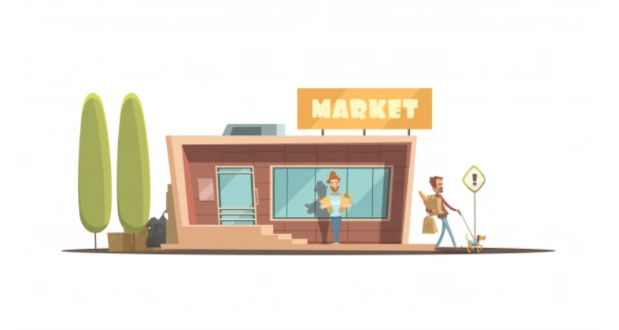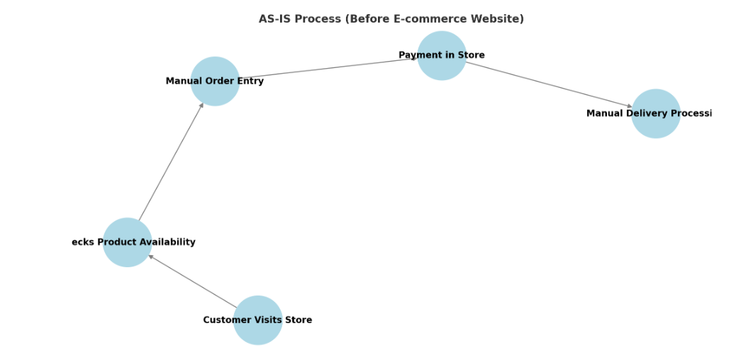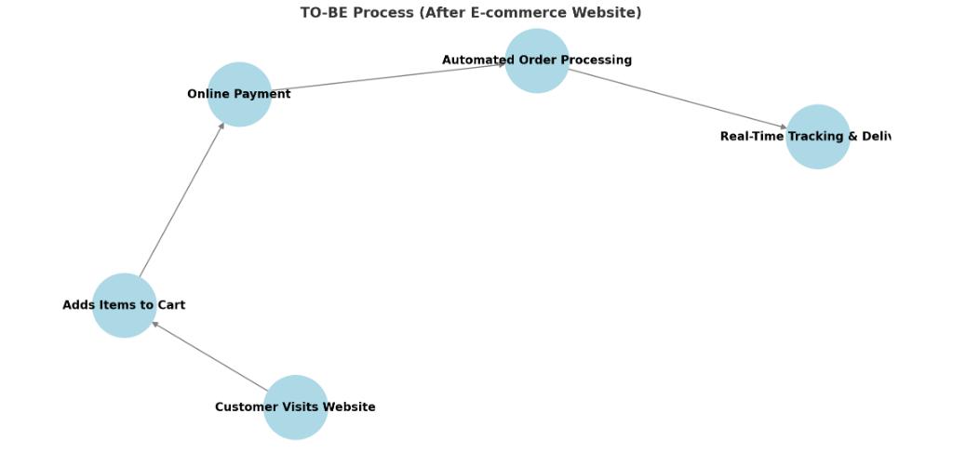1️⃣ **AS-IS Process (Before E-commerce Website)** – Customers visit the store, check product availability manually, place orders, and make payments in-store, leading to manual order processing.

2️⃣ **TO-BE Process (After E-commerce Website)** – Customers browse products online, add items to their cart, complete payments digitally, and track orders in real-time, leading to automated order processing.

**9. Business Requirements**

| **Req ID** | **Requirement** | **Description** | **Priority** |
| --- | --- | --- | --- |
| BR0001 | User Authentication | The website must provide secure login mechanisms for users, including password protection and multi-factor authentication. | High |
| BR0002 | Role-Based Access Control | The website should support role-based access control, allowing administrators, sellers, and customers to have appropriate access levels. | High |
| BR0003 | Product Management | The website should allow sellers to add, update, and manage product listings, including images, descriptions, and pricing. | High |
| BR0004 | Secure Payments | The website must include secure and diverse payment gateways (credit card, PayPal, UPI, etc.) for safe transactions. | High |
| BR0005 | Order Tracking | The website should provide customers with real-time tracking updates for their orders, from placement to delivery. | High |
| BR0006 | Inventory Management | The website should enable sellers to manage inventory levels, notify them of low stock, and allow bulk updates. | High |
| BR0007 | Responsive UI | The website should have a responsive user interface that ensures smooth usability on desktops, tablets, and smartphones. | High |
| BR0008 | Customer Reviews | The website should allow customers to submit reviews and ratings for purchased products to promote transparency and trust. | Medium |
| BR0009 | Reporting and Analytics | The website should provide detailed analytics for sellers, including sales trends, traffic analysis, and customer behavior reports. | Medium |
| BR0010 | Wishlist Feature | The website should enable customers to create and manage wishlists for products they are interested in buying later. | Low |
| BR0011 | Personalized Recommendations | The website should use customer behavior data to provide personalized product recommendations. | Medium |
| BR0012 | Search Functionality | The website should include a robust search bar with advanced filters for categories, price range, ratings, and more. | High |
| BR0013 | Chat Support | The website should include a live chat feature to provide instant assistance to customers. | Medium |
| BR0014 | Discount and Promotions | The website should allow sellers to create discount coupons, run promotions, and highlight special offers on products. | Medium |
| BR0015 | Social Media Integration | The website should enable sharing of products on social media platforms and allow users to log in with their social media accounts. | Low |
| BR0016 | Product Comparison | The website should provide a feature for customers to compare similar products based on specifications and pricing. | Medium |
| BR0017 | Abandoned Cart Reminder | The website should send email or SMS reminders to customers for products left in their cart. | Medium |
| BR0018 | Multiple Delivery Options | The website should offer customers various delivery options, such as express delivery, standard shipping, or store pickup. | High |
| BR0019 | Multi-Language Support | The website should support multiple languages to cater to diverse customer bases. | Low |
| BR0020 | Fraud Detection | The website should have fraud detection mechanisms in place to identify suspicious transactions and protect user data. | High |

**10.Appendices**

**10.1 List of Acronyms**

RACI – Responsible, Accountable, Consulted, Informed (Stakeholder Matrix)

FRD – Functional Requirements Document

NFR – Non-Functional Requirement

SRS – Software Requirements Specification

RTM – Requirements Traceability Matrix

QA – Quality Assurance

QC – Quality Control

UAT – User Acceptance Testing

ROI – Return on Investment

**10.2. Glossary of Terms**

#### **1. Business & E-commerce Terms**

* **E-commerce** – The buying and selling of goods/services over the internet.
* **B2C (Business-to-Consumer)** – A business model where products are sold directly to individual consumers.
* **B2B (Business-to-Business)** – A business model where companies sell products or services to other businesses.
* **Shopping Cart** – A virtual cart that holds items a user wants to purchase.
* **Checkout Process** – The steps a customer follows to complete a purchase.
* **Payment Gateway** – A service that processes credit card and other online payments.
* **Order Fulfillment** – The process of receiving, processing, and delivering an order to the customer.
* **Return Policy** – The terms under which customers can return or exchange products.

#### **2. Business Analysis Terms**

* **BRD (Business Requirements Document)** – A document that outlines the business objectives and requirements.
* **FRD (Functional Requirements Document)** – A document that details how the system should function to meet business needs.
* **Stakeholder** – Any person or group affected by the project (e.g., customers, business owners, developers).
* **Use Case** – A description of how users will interact with the system to achieve a goal.
* **User Story** – A short, simple description of a feature from an end-user’s perspective.
* **UAT (User Acceptance Testing)** – Testing conducted by end-users to verify if the system meets business requirements.

#### **3. Website & UX/UI Terms**

* **UI (User Interface)** – The visual design and layout of the website.
* **UX (User Experience)** – The overall experience a user has while interacting with the website.
* **Responsive Design** – A design approach that ensures the website works on different screen sizes (mobile, tablet, desktop).
* **Wireframe** – A basic visual representation of a webpage's structure.
* **Navigation Menu** – A set of links that help users browse different sections of the website.

#### **4. Technology & Development Terms**

* **CMS (Content Management System)** – A platform (e.g., WordPress, Shopify) used to manage website content.
* **API (Application Programming Interface)** – A set of rules that allows different software systems to communicate.
* **Database** – A structured collection of data, such as customer orders and product details.
* **Backend** – The server-side part of the website that manages data and business logic.
* **Frontend** – The user-facing side of the website that displays content and interacts with users.
* **SEO (Search Engine Optimization)** – Techniques used to improve the website’s ranking on search engines like Google.

#### **5. Security & Compliance Terms**

* **SSL (Secure Sockets Layer)** – A security protocol that encrypts data between the website and users.

**10.3. Related Documents**

#### **1. Business & Requirements Documents**

* **Business Requirements Document (BRD)** – Outlines business needs, goals, and objectives.
* **Functional Requirements Document (FRD)** – Describes the system's features and functionalities.
* **Non-Functional Requirements Document (NFRD)** – Defines performance, security, and usability standards.
* **User Stories & Use Case Document** – Provides real-world scenarios of how users interact with the website.

#### **2. Design & Development Documents**

* **Wireframes & UI/UX Design Mockups** – Visual representations of web pages and user interface.
* **Database Schema Document** – Defines the structure of the database, including tables and relationships.
* **API Documentation** – Provides details about third-party integrations, payment gateways, and internal APIs.

#### **3. Testing & Quality Assurance Documents**

* **Test Plan & Test Cases Document** – Lists the testing approach and scenarios for UAT, functional, and performance testing.
* **User Acceptance Testing (UAT) Report** – Summarizes the results of user testing and feedback.
* **Bug Tracking Report** – Documents identified issues and their resolutions during development.

#### **4. Security & Compliance Documents**

* **SSL & Security Configuration Document** – Details security measures, including encryption and authentication methods.

#### **5. Project Management & Deployment Documents**

* **Project Plan & Timeline** – Includes project milestones, deadlines, and deliverables.
* **RACI Matrix (Roles & Responsibilities)** – Defines who is responsible, accountable, consulted, and informed.

[**Home Heaven Part 1**](https://docs.google.com/document/d/1_h--WbFSZVtROzO1h1BLvZ5lZYBWcYQC7R-Dj5as334/edit?tab=t.0)**( Link to view)**